**The Virtual Revolution: How VR is Transforming the Workplace**

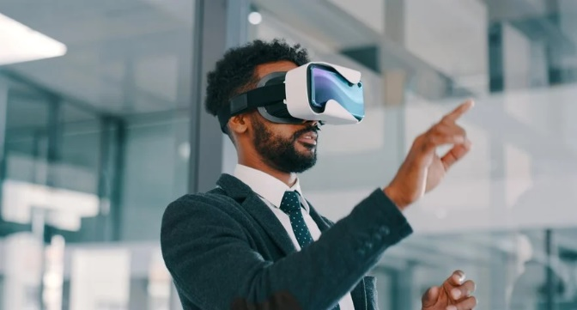Virtual Reality (VR) technology, once a novelty, has rapidly evolved to become a game-changer in the modern workplace. From remote collaboration and employee training to enhanced productivity, VR is making its mark as a powerful tool for transforming the way we work. In this article, we will explore the impact of VR on the workplace, detailing its diverse applications and how it is redefining the concept of work itself.

**The Rise of Virtual Reality in the Workplace**

VR in the workplace is no longer a concept from science fiction; it is a reality that has found its place in various industries. The following are some of the key areas where VR is making a significant impact:

**1. Remote Collaboration and Communication**

Remote work, increasingly prevalent in the modern workforce, has been greatly facilitated by VR technology. Virtual meeting spaces and collaboration tools have redefined the way teams connect. With VR headsets and software, employees can interact as if they were in the same physical location, fostering a sense of presence and making meetings more engaging. This technology is especially valuable for global teams, reducing the limitations of time zones and physical distance.

**2. Employee Training and Development**

VR is revolutionizing the way companies train their employees. In industries where hands-on training is essential, such as aviation, healthcare, and manufacturing, VR offers a safe and cost-effective solution. Employees can practice complex procedures, make mistakes without real-world consequences, and gain practical experience in a controlled environment. This not only reduces the risk of accidents but also accelerates the learning curve.

**3. Enhancing Productivity**

VR can be a catalyst for increased productivity in the workplace. It offers a unique environment where employees can focus without distractions, making it an ideal tool for tasks that require deep concentration, such as data analysis or software development. Furthermore, the use of VR can enhance workflow processes, from data visualization to 3D modeling and design. For instance, architects and engineers can visualize complex projects in 3D, making it easier to identify potential issues and streamline project development.

**4. Recruitment and Onboarding**

VR is changing the way companies attract and onboard talent. Instead of merely reading about company culture or watching videos, new hires can immerse themselves in a virtual tour of the workplace, get to know their colleagues, and engage in interactive onboarding experiences. This not only improves the understanding of company culture but also expedites the integration of new employees into the organization.

**Addressing Workplace Challenges**

The impact of VR on the workplace extends to addressing common challenges faced by organizations:

**1. Cost Reduction**

VR offers a cost-effective solution for training and development. Companies can save on expenses related to physical training facilities, travel, and materials. This is particularly advantageous for organizations with a global workforce or those that require frequent employee training.

**2. Safety and Risk Mitigation**

In high-risk industries, such as construction and manufacturing, VR provides a safe environment for employees to familiarize themselves with potential hazards and practice safety protocols. This minimizes the risk of accidents and injuries, ultimately reducing workplace-related costs and legal liabilities.

**3. Accessibility and Inclusivity**

VR technology is becoming more accessible and user-friendly, ensuring that employees with disabilities can also benefit from its applications. For instance, individuals with mobility impairments can participate in virtual meetings and training sessions on equal footing with their peers.

**Conclusion**

The integration of Virtual Reality in the workplace is not merely a technological trend; it is a fundamental shift in the way we approach work. The impact of VR is felt across various industries, revolutionizing how we collaborate, train, and perform our daily tasks. The workplace of the future will be more immersive, inclusive, and efficient, thanks to the transformative power of VR. As the technology continues to evolve and become more accessible, it is crucial for businesses to embrace it as a strategic tool for staying competitive and meeting the changing demands of the modern workforce. VR is not just about virtual experiences; it's about redefining the future of work.